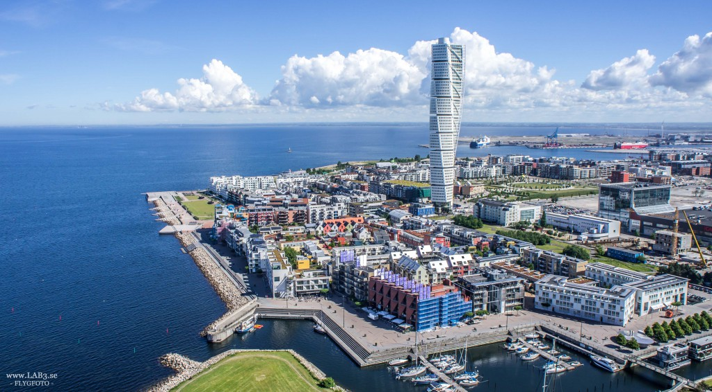

Lady A
Greece | Spain | 1-2
Russia | Germany | 9-1
Sweden | Turkey | 3-7
Germany | Greece | 3-1
Spain | Sweden | 3-8
Turkey | Russia | 6-2
Sweden | Germany | 4-5
Spain | Turkey | 1-11
Greece | Russia | 1-3
Germany | Spain | 9-6
Turkey | Greece | 7-0
Russia | Sweden | 6-3
Spain | Russia | 1-11
Germany | Turkey | 4-6
Greece | Sweden | 3-2

Turkey | 37-10 | 15
Russia | 31-12 | 12
Germany | 22-26 | 9
Sweden | 20-24 | 3
Greece | 6-17 | 3
Spain | 13-40 | 3

Lady B
Japan | Belgium | 10-0
USA | Great Britain | 8-2
Finland | Denmark | 5-2
Great Britain | Japan | 0-4
Belgium | Finland | 1-10
Denmark | USA | 0-10
Finland | Great Britain | 5-4
Belgium | Denmark | 1-4
Japan | USA | 1-2
Great Britain | Belgium | 8-2
Denmark | Japan | 2-1
USA | Finland | 3-2
Belgium | USA | 2-12
Great Britain | Denmark | 4-3
Japan | Finland | 2-0

USA | 35-7 | 15
Japan | 18-4 | 9
Finland | 22-12 | 9
Great Britain | 18-22 | 6
Denmark | 11-21 | 6
Belgium | 6-44 | 0

Lady Playoffs
Semi | Turkey | Japan | 3-0
Semi | USA | Russia | 2-1
11-12 | Spain | Belgium | 9-2
9-10 | Greece | Denmark | 5-0
7-8 | Sweden | Great Britain | 3-0
5-6 | Germany | Finland | 2-3
Bronze | Japan | Russia | 2-1
Final | Turkey | USA | 2-3 sd
Men
Belgium | Japan | 8-3
Germany | Finland | 3-7
Sweden | Hungary | 6-8
Turkey | Japan | 8-3
Belgium | Germany | 11-7
Finland | Sweden | 10-0
Hungary | Turkey | 3-7
Japan | Finland | 5-15
Sweden | Belgium | 4-14
Germany | Turkey | 2-5
Finland | Hungary | 5-3
Japan | Sweden | 5-12
Turkey | Finland | 6-4
Germany | Japan | 11-10
Hungary | Belgium | 5-8
Sweden | Germany | 11-7
Japan | Hungary | 8-6
Belgium | Turkey | 3-3
Finland | Belgium | 5-12
Hungary | Germany | 4-7
Turkey | Sweden | 10-5

Belgium | 56-27 | 16
Turkey | 39-20 | 16
Finland | 46-29 | 12
Germany | 37-48 | 6
Sweden | 38-54 | 6
Hungary | 29-41 | 3
Japan | 34-60 | 3

Men Playoffs
Final | Belgium | Turkey | 2-11

Final standings
 | Lady | Men
1 | USA | Turkey
2 | Turkey | Belgium
3 | Japan | Finland
4 | Russia | Germany
5 | Finland | Sweden
6 | Germany | Hungary
7 | Sweden | Japan
8 | Great Britain
9 | Greece
10 | Denmark
11 | Spain
12 | Belgium

Lady Top Scorer
1 | Sumeyye | Özcan | TUR | 27
2 | Laura | Belle | ESP | 17
3 | Amanda | Dennis | USA | 16
4 | Krista | Leppänen | FIN | 15
5 | Natascha | Bretzke | GER | 14
6 | Lisa | Czechowski | USA | 13
7 | Malin | Gustavsson | SWE | 11
8 | Swetlana | Otto | GER | 10
 | Anastasia | Mazur | RUS | 10
 | Laura | Perry | GBR | 10
11 | Olga | Likhatckaia | RUS | 8
12 | Georgie | Bullen | GBR | 8
 | Karina | Jørgensen | DEN | 8
14 | Gulsah | Akturk | TUR | 7
 | Natalia | Kochurova | RUS | 7
 | Aikiko | Adachi | JPN | 7
 | Asya | Miller | USA | 7
18 | Seda | Yildiz | TUR | 6
 | Kaisu | Hynninen | FIN | 6
20 | Maria | Wåglund | SWE | 5
21 | Irina | Arestova | RUS | 4
 | Haruka | Wakasugi | JPN | 4
 | Yuki | Temma | JPN | 4
24 | Maria | Tzalla | GRE | 3
 | Theodora | Paschalidou | GRE | 3
 | Konstantina | Driva | GRE | 3
 | Viktoria | Andersson | SWE | 3
 | Lidia | Banos | ESP | 3
 | Eiko | Kakehata | JPN | 3
 | Iida | Kauppila | FIN | 3
 | Marybai | Huking | USA | 3
 | Naomi | Blomme | BEL | 3
 | Charlotte | Scheelen | BEL | 3
34 | Sofia | Naesström | SWE | 2
 | Lisa | Ly | SWE | 2
 | Sadiye | Ardic | TUR | 2
 | Sarah | Leiter | GBR | 2
 | Anja | Christensen | DEN | 2
 | Benedicte | Aertsens | BEL | 2
40 | Vasiliki | Agko | GRE | 1
 | Aikaterini | Lorentzou | GRE | 1
 | Victoria | Leontyeva | RUS | 1
 | Anna | Shevchenko | RUS | 1
 | Eukene | Esain | ESP | 1
 | Maider | Santesteban | ESP | 1
 | Rie | Urata | JPN | 1
 | Andrea | Logan | GBR | 1
 | Raisa | Kuusela | FIN | 1
 | Beritan | Fener | DEN | 1
 | Eliana | Mason | USA | 1

Men Top Scorer
1 | Ekrem | Gondogdu | TUR | 27
2 | Jarno | Mattila | FIN | 21
3 | Klison | Mapreni | BEL | 20
 | Erkki | Miinala | FIN | 20
4 | Youssef | Bihi | BEL | 19
 | Michael | Feistle | GER | 19
 | Fatmir | Seremeti | SWE | 19
7 | Bruno | Vanhove | BEL | 16
 | Stefan | Gahne | SWE | 16
9 | Masatoshi | Ito | JPN | 9
 | Maki | Tsujimura | JPN | 9
 | Zsolt | Orsós | HUN | 9
 | Zsolt | Majzik | HUN | 9
 | Tuncay | Karakaya | TUR | 9
14 | Yoshu | Nobusawa | JPN | 8
15 | Oliver | Hörauf | GER | 7
 | Yunus Emre | Akyuz | TUR | 7
17 | Stefan | Hawranke | GER | 6
18 | Gábor | Bukta | HUN | 5
19 | Rikiya | Kudo | JPN | 4
 | Balázs | Száraz | HUN | 4
 | Huseyin | Alkan | TUR | 4
22 | Thomas | Steiger | GER | 3
23 | Glenn | Van Thournout | BEL | 2
 | Petteri | Peitso | FIN | 2
 | Mikko | Viittala | FIN | 2
 | Dzenan | Ajdinovic | SWE | 2
 | Sercan | Kaya | TUR | 2
28 | Tom | Vanhove | BEL | 1
 | Reno | Tiede | GER | 1
 | Eetu | Eronen | FIN | 1
 | Mikael | Åkerberg | SWE | 1
 | Ernó | Haffner | HUN | 1
 | Abdullah | Aydogdu | TUR | 1

Please help us to spread this date to all nations that you think can be interested to participate. You can already now book your spot at bjorkstrand@telia.com.

