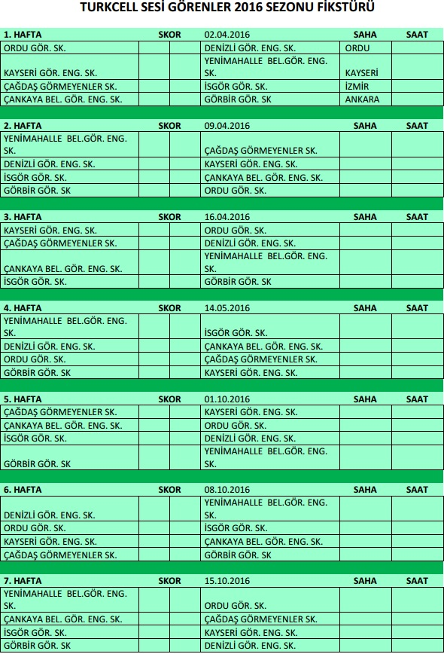

10.30

10.30

10.30

10.30

10.30

10.30

10.30

10.30

10.30

10.30

10.30

10.30

10.30

10.30

10.30

10.30

10.30

10.30

10.30

10.30

10.30

10.30

10.30

10.30

10.30

10.30

10.30

10.30

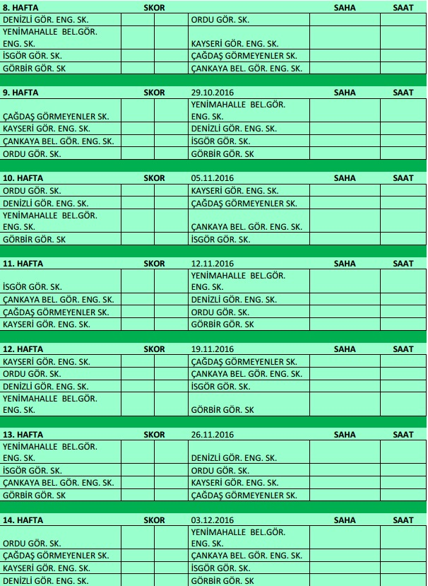

30.

**22.10.2016**

10.30

10.30

10.30

10.30

10.30

10.30

10.30

10.30

10.30

10.30

10.30

10.30

10.30

10.30

10.30

10.30

10.30

10.30

10.30

10.30

10.30

10.30

10.30

10.30

10.30

10.30

10.30

10.30